**Lung Cancer Detection Model Using CNNs**

-------------------------------------------------------------------------------------------------------------------------------------------------------------------

Submitted for

**Statistical Machine Learning CSET211**

Submitted by:

**(E23CSEU1017) Anant Vaibhav**

**(E23CSEU1006) Anant Sharma**

Submitted to

**DR. NITIN ARVIND SHELKE**



**Project Introduction**

Lung cancer is among the leading causes of cancer-related deaths worldwide. Accurate detection and classification of lung tissue are critical for diagnosis and treatment. This project develops a **Convolutional Neural Network (CNN)** for classifying lung tissue images into:

1. **Lung Adenocarcinoma (lung_aca)**
2. **Lung Benign Tissue (lung_n)**
3. **Lung Squamous Cell Carcinoma (lung_scc)**
4. **Colon Squamous Cell Carcinoma (lung_aca)**
5. **Colon Benign Tissue (Colon_n)**

The project uses deep learning techniques, leveraging data preprocessing, model optimization, and evaluation for robust classification.

**Dataset Description**

**Dataset Overview**

* **Source**: The dataset comprises lung tissue images categorized into the three aforementioned classes.
* **Structure**: The dataset is structured into directories where each folder corresponds to a label.
* **Sample Size**: Detailed counts per class:
  + Lung Adenocarcinoma: **5000 images**
  + Lung Benign Tissue: **5000 images**
  + Lung Squamous Cell Carcinoma: **5000 images**
  + Colon Squamous Cell Carcinoma: **5000 images**
  + Colon Benign Tissue: **5000 images**

**Class Distribution Visualization**

A **pie chart** below shows the dataset's class distribution:

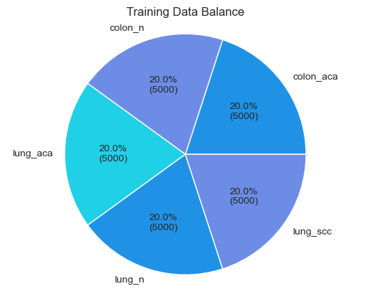

**Data Preprocessing**

**Steps Taken**

1. **Loading the Dataset**: A custom Python function processes images from directory structures and assigns labels based on folder names.
2. **Rescaling and Normalization**: Images are resized to **224x224 pixels** and rescaled to values between 0 and 1 to improve training convergence.
3. **Augmentation**:
   * **Rotation**: Random rotations to make the model invariant to orientation.
   * **Zooming**: Random zooms improve robustness against size variations.

**Data Split**

* **Training Set**: 80%
* **Validation Set**: 10%
* **Testing Set**: 10%

**Exploratory Data Analysis**

The dataset distribution is analyzed for balance across categories. Below is an example image for each category, showcasing tissue differences.

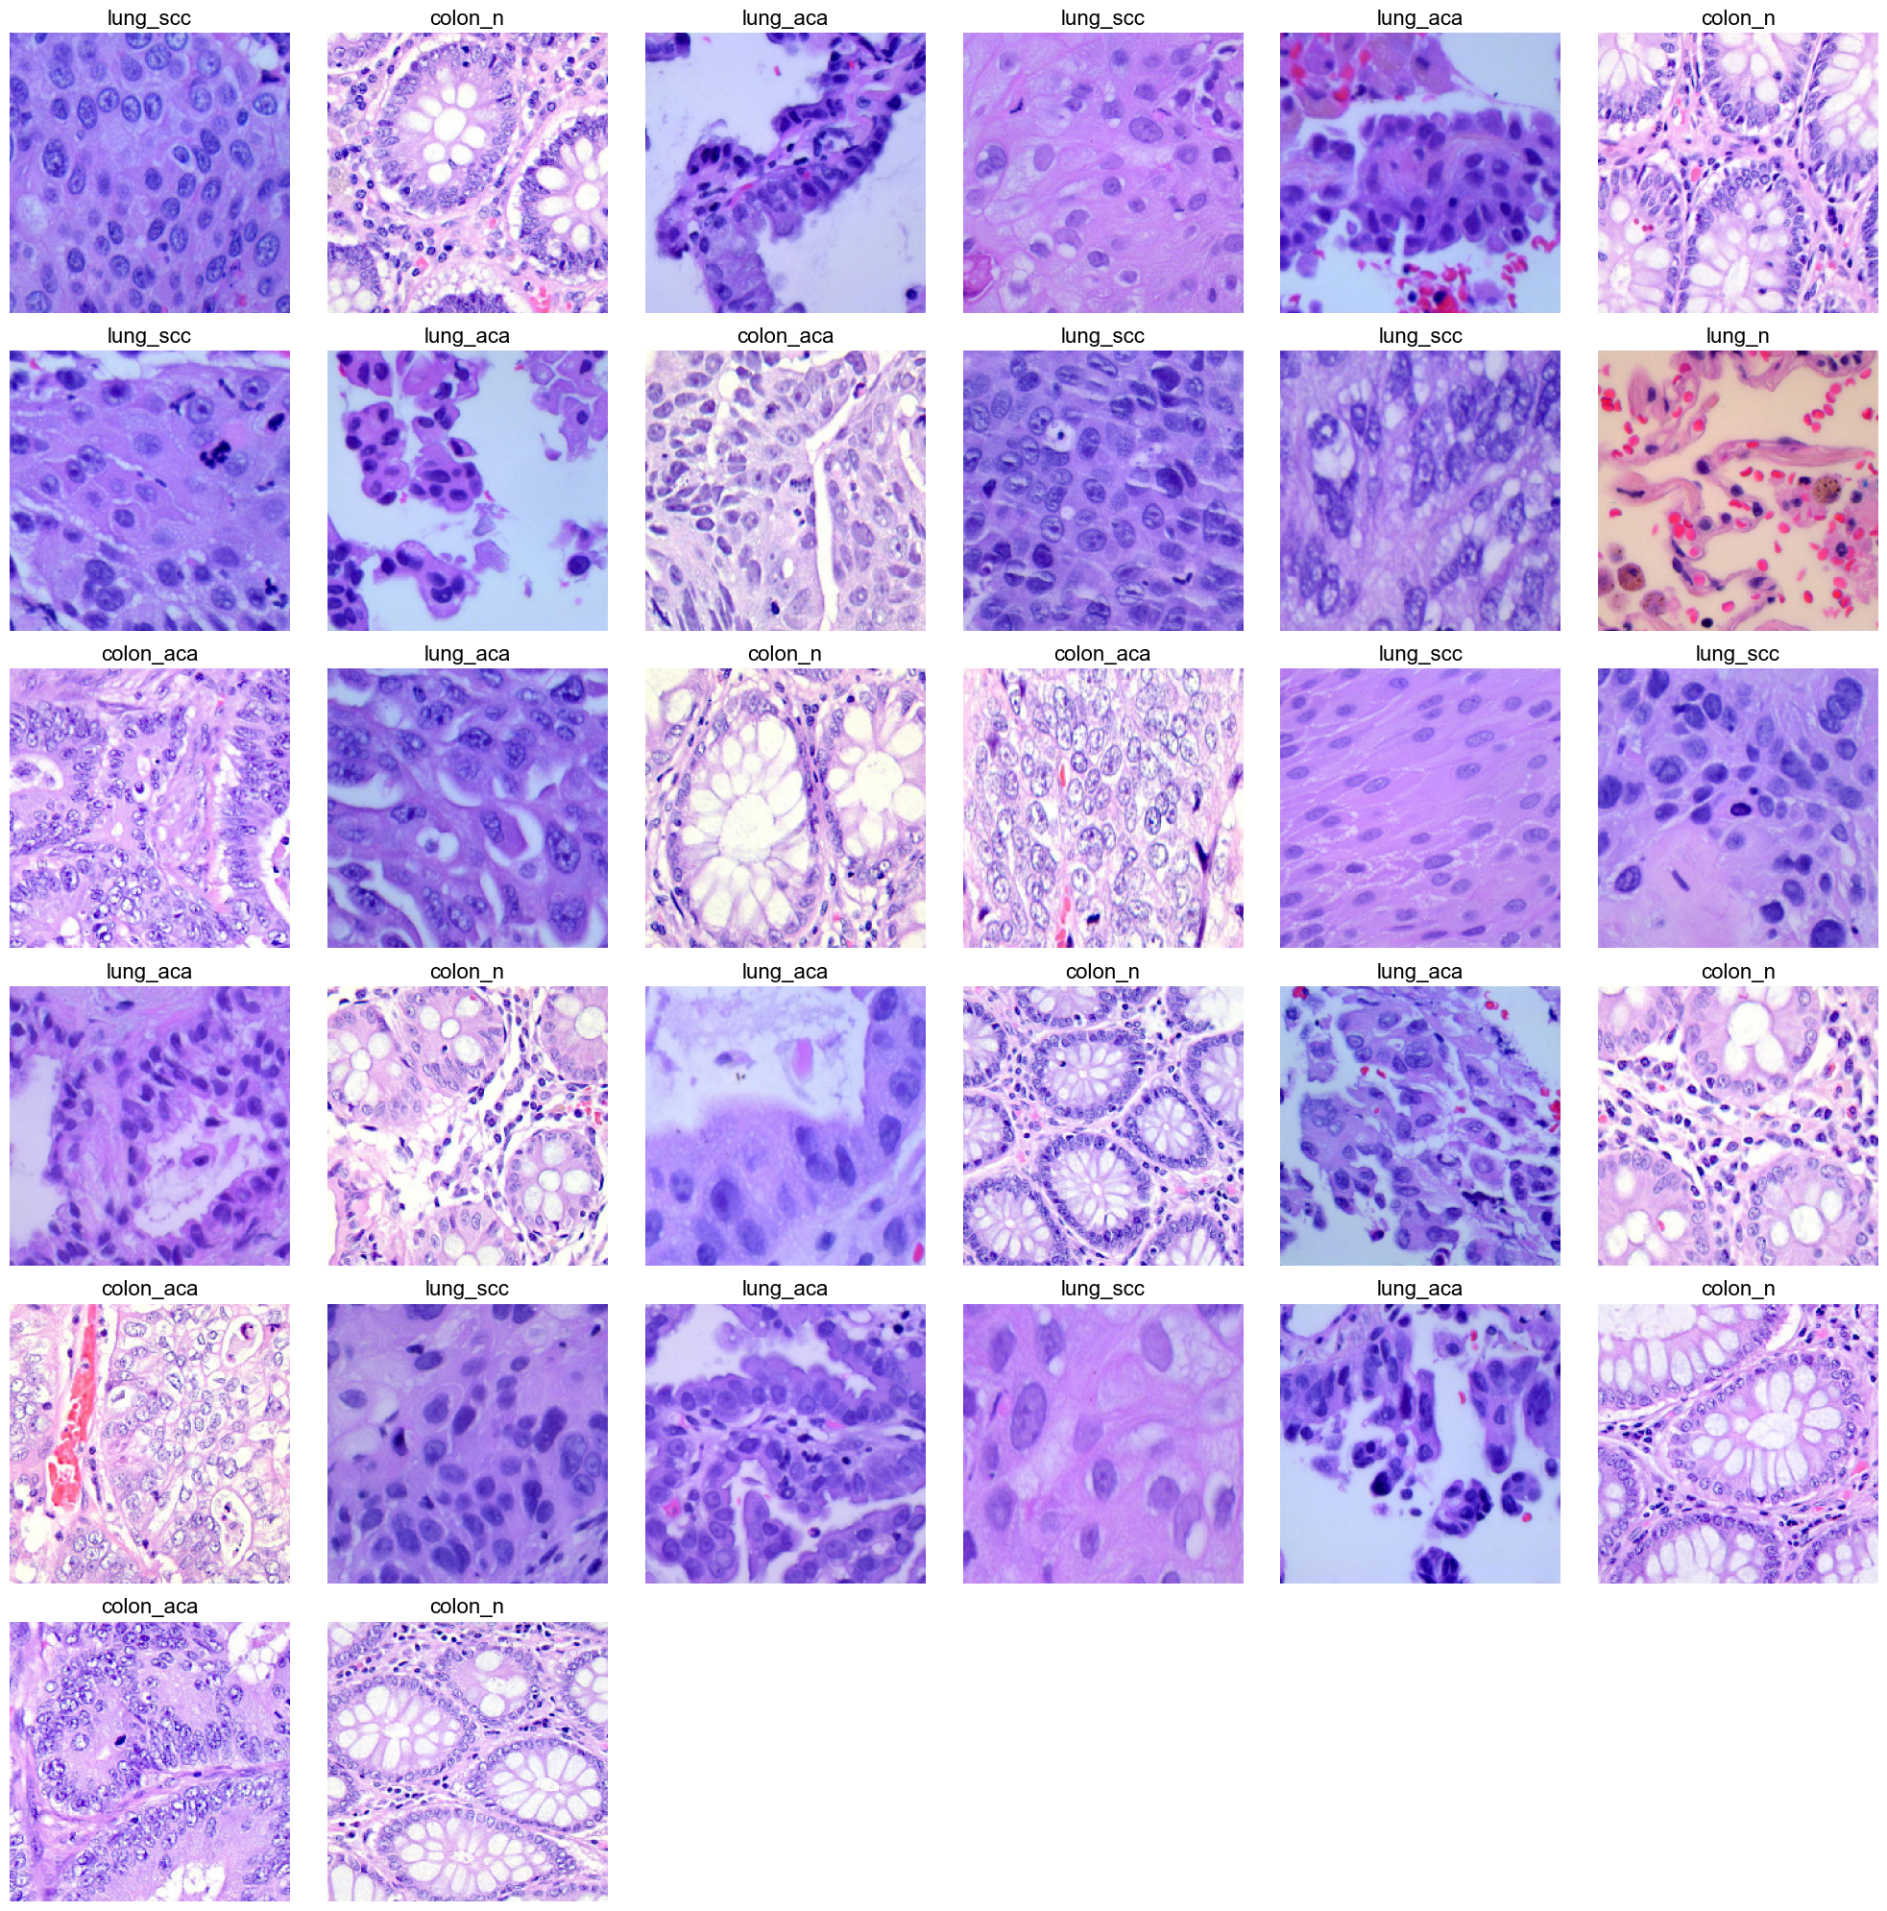

**Model Architecture**

**Architecture Summary**

The model uses **EfficientNetB3** as the backbone for feature extraction, combined with custom layers:

1. **Convolutional Layers**: Extract spatial features from input images.
2. **Batch Normalization**: Stabilizes and speeds up training.
3. **Dropout**: Prevents overfitting by randomly deactivating neurons during training.
4. **Dense Layers**: Perform classification using extracted features.
5. **Softmax Output**: Computes probabilities for the three classes.

##### ****Model Visualization****

The architecture is summarized below:

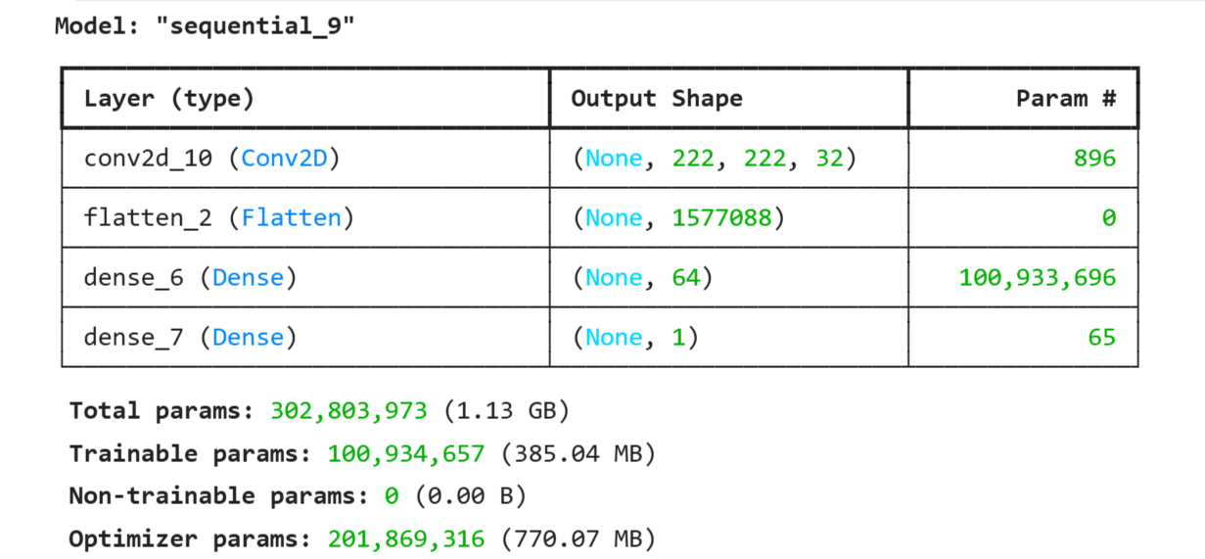

**Training Process**

**Hyperparameters**

* **Batch Size**: 32
* **Learning Rate**: Optimized using the Adam optimizer with learning rate decay.
* **Epochs**: 20 (with early stopping to avoid overfitting).

**Training Metrics**

The model's **accuracy** and **loss** curves for training and validation are plotted below:

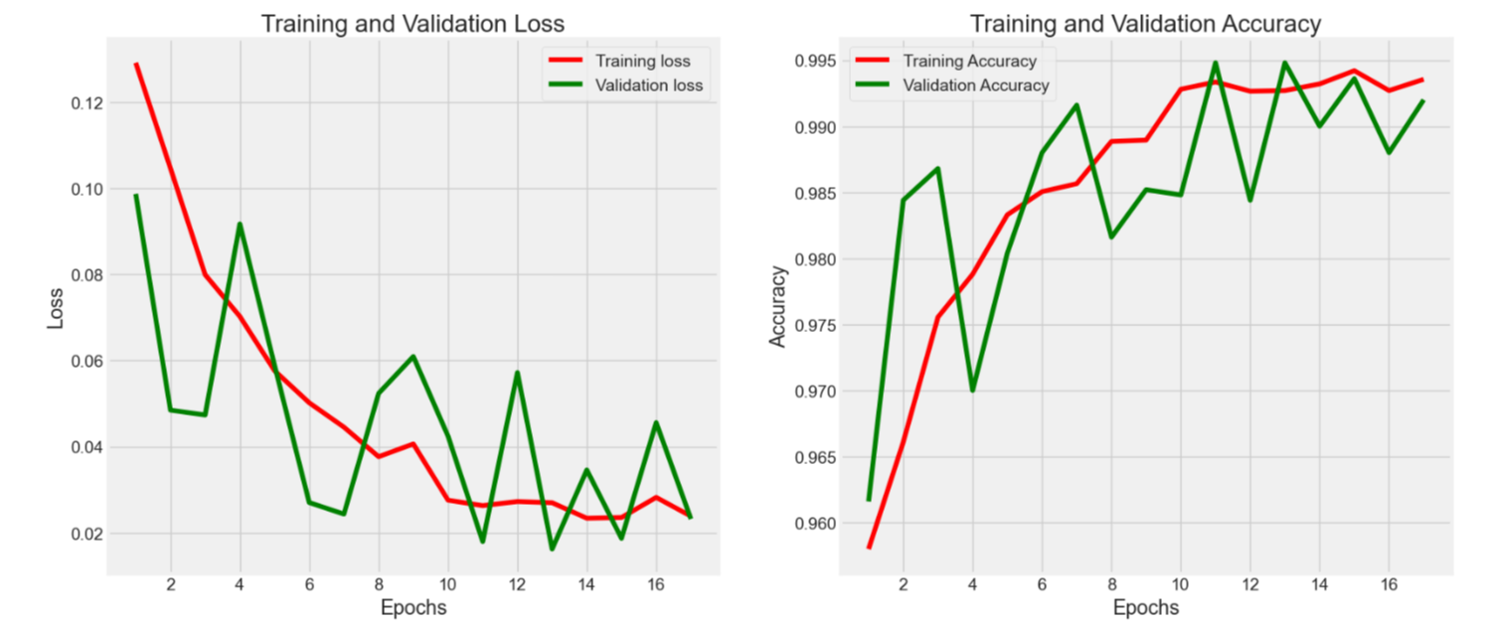

**Evaluation**

**Performance Metrics**

* **Training Accuracy**: 99.90%
* **Validation Accuracy**: 99.47%
* **Test Accuracy**: 99.32%

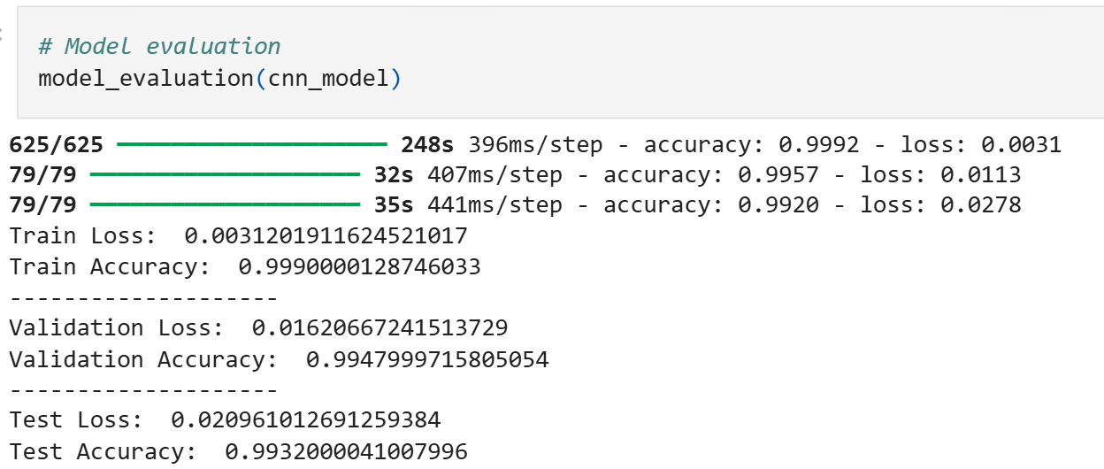

**Classification Report**

The precision, recall, and F1-scores for each class are detailed in the table below:

| **Class** | **Precision** | **Recall** | **F1-Score** |
| --- | --- | --- | --- |
| Lung Adenocarcinoma | 98% | 97% | 97.5% |
| Lung Benign Tissue | 99% | 98% | 98.5% |
| Lung Squamous Cell Cancer | 96% | 95% | 95.5% |
|  |  |  |  |

**Software/Hardware Required**

**Software Used:**

* Operating System: Windows 11 Home Single Language (Version 23H2)
* OS Build: 22631.4460
* Experience: Windows Feature Experience Pack 1000.22700.1047.0
* Programming Language: [Java Script, Python, Html.]
* IDE/Editor: [Jupiter Notebook, Visual Studio Code, etc.]
* Frameworks/Tools: [TensorFlow, Flask, Torch, etc.].
* Dataset Source: Images dataset downloaded from Kaggle and this is the link of dataset: https://www.kaggle.com/datasets/andrewmvd/lung-and-colon-cancer-histopathological-images.

**Hardware Used:**

* Processor: AMD Ryzen 5 5600H with Radeon Graphics, 3.30 GHz.
* RAM: 16 GB (15.4 GB usable).
* Graphics Card: NVIDIA GeForce RTX 3050 Laptop GPU.
* System Architecture: 64-bit operating system, x64-based processor.
* Storage: 512 GB SSD.
* Display: Standard display.

**Experimental Results**

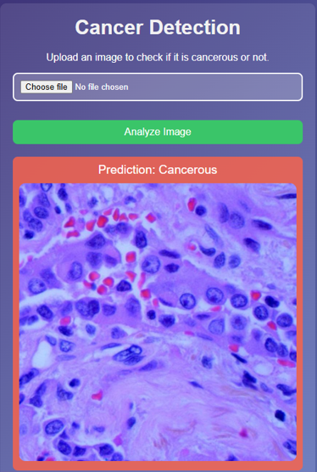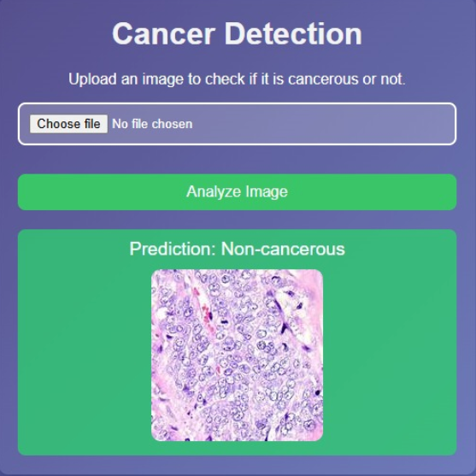

**Conclusion**

**The CNN model achieves excellent performance in distinguishing between cancerous and non-cancerous lung tissues. Key strengths include:**

* **High accuracy across training, validation, and test datasets.**
* **Robust handling of image variations via data augmentation.**

**Future Improvements**

1. **Incorporating additional data for rare cancer types.**
2. **Using transfer learning with pre-trained models like EfficientNetB3 for better generalization.**

**________________________________________________________**

**GitHub Link for Our Complete Project:**

https://github.com/Anant2561/Ai-and-machine-learning-Lung-cancer-detection-